Python CLI Application
To-Do List Manager
Week 1 Task — Python Development Internship
Design, Implementation, Documentation & Testing
This document contains the complete deliverable for the Week 1 CLI To-Do List Manager task: the application design and architecture, a visual flow diagram, full annotated source code, the README (installation, usage, and design rationale), and evidence of automated and manual testing.

1. Task Objective
Develop a command-line interface (CLI) Python application that functions as a simplified To-Do List Manager, emphasizing planning, modular design, and clean, maintainable code.
Core requirements addressed in this submission:
- Add, view, complete, and remove tasks
- Object-oriented design with clear module separation
- Robust input validation and error handling
- Persistent storage between runs
- Inline code comments explaining design decisions
- A README with setup/run instructions and design rationale
- Automated and manual test coverage

2. Application Architecture & Design
The application is split into three layers, following the separation-of-concerns principle:
Layer | File | Responsibility
Data model | task.py | Represents a single task; converts to/from a dictionary for JSON storage. No knowledge of the UI or file system.
Business logic | task_manager.py | Owns the task list; handles add/remove/complete/filter and JSON save/load. Contains all validation rules. No direct input()/print() calls.
Interface | cli.py + main.py | Shows menus, reads/validates raw input, calls TaskManager methods, prints results. Contains no business rules of its own.

Why this structure?
- Testability — task_manager.py can be unit-tested without simulating keyboard input.
- Maintainability — new rules (e.g. due dates) only require changes in one place.
- Reusability — TaskManager could power a future GUI or web front-end unchanged.
Persistence uses a plain JSON file (tasks.json) instead of a database, since this is a single-user CLI tool — JSON needs no setup, no dependencies, and is easy to inspect by hand.

3. Application Flow Diagram
The diagram below traces the program from startup through the main menu loop, each of the seven options, their validation branches, and back to the loop until Exit is chosen.
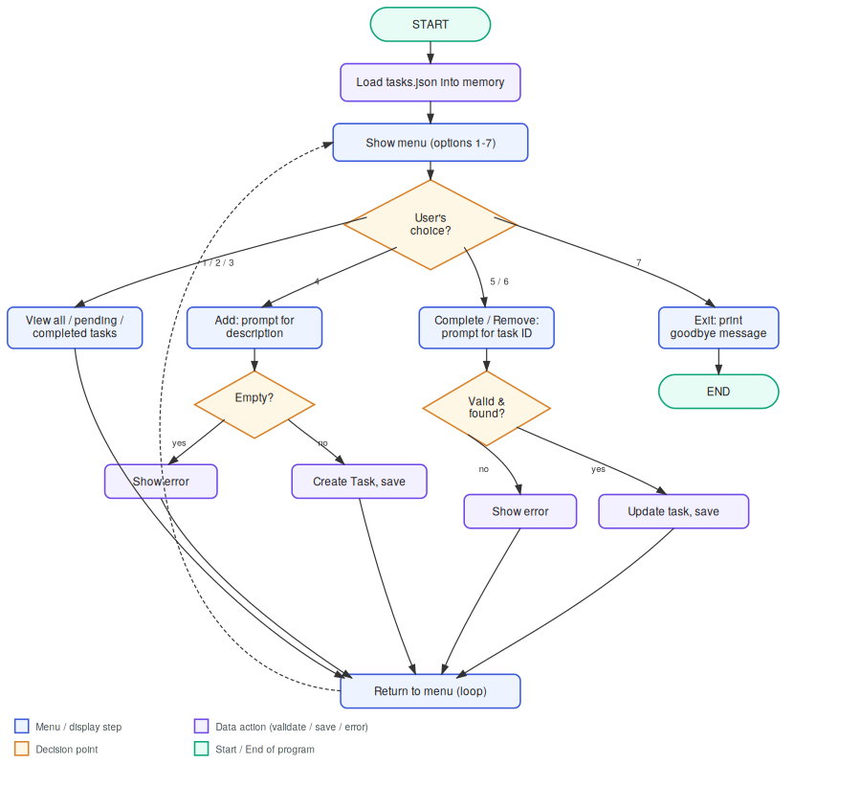

4. Pseudocode
START
Load tasks from tasks.json (if it exists) into memory
LOOP forever:
Show menu (View all / pending / completed, Add, Complete, Remove, Exit)
Read user's menu choice
IF choice is "Add":
Ask for description
IF description is empty -> show error, loop again
ELSE -> create Task, assign next ID, append to list, save to file
IF choice is "Complete":
Ask for task ID
IF ID is not a number -> show error, loop again
IF ID not found -> show error, loop again
ELSE -> mark task completed, save to file
IF choice is "Remove":
(same ID validation as above)
ELSE -> remove task from list, save to file
IF choice is "View ...":
Filter task list (all / pending / completed) and print it
IF choice is "Exit":
Print goodbye message, break loop
END LOOP
END

5. Full Source Code
All four application modules are reproduced in full below, with the original inline comments explaining each design decision.
task.py
Data model — represents a single to-do item.
"""
task.py
-------
Defines the Task class: a simple data model representing one to-do item.

DESIGN CHOICE:
We keep this class "dumb" on purpose — it only knows how to hold and
serialize its own data. It has NO knowledge of files, menus, or the
TaskManager. This keeps responsibilities separated: if tomorrow we
wanted to add a "priority" field, we'd only touch this file.
"""

from datetime import datetime

class Task:
"""Represents a single to-do item."""

def __init__(self, description, completed=False, created_at=None, task_id=None):
self.id = task_id # Assigned by TaskManager; None until added to a list
self.description = description
self.completed = completed
# Store creation timestamp as a string so it's easy to save/load as JSON
self.created_at = created_at or datetime.now().strftime("%Y-%m-%d %H:%M:%S")

def mark_complete(self):
"""Flip this task's status to completed."""
self.completed = True

def mark_incomplete(self):
"""Allow un-completing a task (useful if marked by mistake)."""
self.completed = False

def to_dict(self):
"""
Convert this Task object into a plain dictionary.
Needed because JSON (used for saving to disk) only understands
basic Python types (dict, list, str, int, bool), not custom objects.
"""
return {
"id": self.id,
"description": self.description,
"completed": self.completed,
"created_at": self.created_at,
}

@classmethod
def from_dict(cls, data):
"""
Rebuild a Task object from a dictionary (the reverse of to_dict).
A classmethod is used here (instead of __init__ directly) because
this is an *alternative constructor* — it builds a Task from saved
data rather than from fresh user input.
"""
return cls(
description=data["description"],
completed=data.get("completed", False),
created_at=data.get("created_at"),
task_id=data.get("id"),
)

def __str__(self):
"""Human-friendly display, used when printing the task list."""
status = "✔" if self.completed else "✘"
return f"[{status}] ({self.id}) {self.description} -- added {self.created_at}"

task_manager.py
Business logic — add/remove/complete/list tasks and JSON persistence.
"""
task_manager.py
----------------
Defines TaskManager: the "business logic" layer of the app.

DESIGN CHOICE:
This class owns the list of Task objects and all the operations on it
(add, remove, complete, view, save, load). It does NOT print anything
to the screen and does NOT ask the user for input directly — that's
the CLI layer's job. This separation means:
- TaskManager could be reused by a future GUI or web version untouched.
- It's easy to unit-test TaskManager without simulating user typing.

Persistence uses a simple JSON file (tasks.json) so tasks survive
between runs. JSON was chosen over a database because it requires
no extra dependencies and is easy to inspect/edit by hand.
"""

import json
import os

class TaskManager:
def __init__(self, storage_file="tasks.json"):
self.storage_file = storage_file
self.tasks = [] # List of Task objects, kept in memory
self._next_id = 1 # Simple auto-incrementing ID counter
self.load_tasks()

# ------------------------------------------------------------------
# Core features
# ------------------------------------------------------------------

def add_task(self, description):
"""
Add a new task. Raises ValueError on invalid input so the CLI
layer can catch it and show a friendly message (input validation
lives partly here because TaskManager should never allow itself
to end up in an invalid state, regardless of which caller uses it).
"""
from task import Task # Local import avoids a circular import at module load time

description = description.strip() if description else ""
if not description:
raise ValueError("Task description cannot be empty.")

new_task = Task(description=description, task_id=self._next_id)
self.tasks.append(new_task)
self._next_id += 1
self.save_tasks()
return new_task

def remove_task(self, task_id):
"""Remove a task by ID. Raises KeyError if not found."""
task = self._find_task(task_id)
self.tasks.remove(task)
self.save_tasks()
return task

def complete_task(self, task_id):
"""Mark a task as completed by ID. Raises KeyError if not found."""
task = self._find_task(task_id)
task.mark_complete()
self.save_tasks()
return task

def list_tasks(self, filter_by="all"):
"""
Return tasks filtered by status.
filter_by: "all" | "pending" | "completed"
"""
if filter_by == "pending":
return [t for t in self.tasks if not t.completed]
if filter_by == "completed":
return [t for t in self.tasks if t.completed]
return list(self.tasks) # "all" (default) — return a copy

# ------------------------------------------------------------------
# Helpers
# ------------------------------------------------------------------

def _find_task(self, task_id):
"""Locate a task by its ID or raise KeyError with a clear message."""
for task in self.tasks:
if task.id == task_id:
return task
raise KeyError(f"No task found with ID {task_id}.")

# ------------------------------------------------------------------
# Persistence
# ------------------------------------------------------------------

def save_tasks(self):
"""Write current tasks to the JSON storage file."""
from task import Task # local import, same reasoning as above

data = [task.to_dict() for task in self.tasks]
try:
with open(self.storage_file, "w", encoding="utf-8") as f:
json.dump(data, f, indent=2)
except OSError as e:
# We don't crash the app if saving fails (e.g. disk full,
# permissions) — we surface it so the user is aware.
print(f"Warning: could not save tasks ({e}).")

def load_tasks(self):
"""Load tasks from the JSON storage file, if it exists."""
from task import Task

if not os.path.exists(self.storage_file):
return # First run — nothing to load yet, that's fine.

try:
with open(self.storage_file, "r", encoding="utf-8") as f:
raw_data = json.load(f)
except (OSError, json.JSONDecodeError) as e:
# Corrupted or unreadable file: start fresh rather than crashing.
print(f"Warning: could not read '{self.storage_file}' ({e}). "
f"Starting with an empty task list.")
return

self.tasks = [Task.from_dict(item) for item in raw_data]
# Recompute next_id so new tasks never collide with loaded ones.
if self.tasks:
self._next_id = max(t.id for t in self.tasks) + 1

cli.py
Interface layer — menu display, input reading, and validation.
"""
cli.py
------
The interactive command-line interface. This module's ONLY job is:
1. Show menus / prompts
2. Read and validate raw user input
3. Call TaskManager methods
4. Print results

It deliberately contains no business logic (no direct list manipulation)
so the "rules" of the to-do list live in exactly one place (task_manager.py).
"""

from task_manager import TaskManager

MENU = """
==============================
TO-DO LIST MANAGER
==============================
1. View all tasks
2. View pending tasks
3. View completed tasks
4. Add a task
5. Mark a task as completed
6. Remove a task
7. Exit
==============================
"""

def print_tasks(tasks):
"""Shared helper to display a list of tasks, or a friendly empty message."""
if not tasks:
print(" (no tasks to show)")
return
for task in tasks:
print(" ", task)

def prompt_for_task_id():
"""
Ask the user for a task ID and validate it's a positive integer.
Returns the integer, or None if the user typed something invalid
(in which case a message has already been printed).
"""
raw = input("Enter task ID: ").strip()
if not raw.isdigit():
print("Invalid input: please enter a numeric task ID.")
return None
return int(raw)

def run():
"""Main application loop."""
manager = TaskManager()

while True:
print(MENU)
choice = input("Choose an option (1-7): ").strip()

# --- View all ---
if choice == "1":
print_tasks(manager.list_tasks("all"))

# --- View pending ---
elif choice == "2":
print_tasks(manager.list_tasks("pending"))

# --- View completed ---
elif choice == "3":
print_tasks(manager.list_tasks("completed"))

# --- Add task ---
elif choice == "4":
description = input("Enter task description: ")
try:
task = manager.add_task(description)
print(f"Added task #{task.id}: {task.description}")
except ValueError as e:
print(f"Error: {e}")

# --- Complete task ---
elif choice == "5":
if not manager.tasks:
print("There are no tasks yet.")
continue
task_id = prompt_for_task_id()
if task_id is None:
continue
try:
task = manager.complete_task(task_id)
print(f"Marked task #{task.id} as completed.")
except KeyError as e:
print(f"Error: {e}")

# --- Remove task ---
elif choice == "6":
if not manager.tasks:
print("There are no tasks yet.")
continue
task_id = prompt_for_task_id()
if task_id is None:
continue
try:
task = manager.remove_task(task_id)
print(f"Removed task #{task.id}: {task.description}")
except KeyError as e:
print(f"Error: {e}")

# --- Exit ---
elif choice == "7":
print("Goodbye! Your tasks have been saved.")
break

else:
print("Invalid option. Please choose a number from 1 to 7.")

main.py
Entry point — starts the CLI and handles a clean Ctrl+C exit.
"""
main.py
-------
Entry point of the application. Kept intentionally tiny: its only
responsibility is to start the CLI and handle a clean Ctrl+C exit.
"""

from cli import run

if __name__ == "__main__":
try:
run()
except KeyboardInterrupt:
# Catch Ctrl+C so the user gets a clean exit message instead
# of a scary traceback.
print("\n\nInterrupted. Exiting without losing saved tasks.")

tests/test_manager.py
Automated unit tests (unittest) covering core behavior and edge cases.
"""
test_manager.py
----------------
Automated test scenarios for TaskManager, using Python's built-in
`unittest` module (no external dependencies required).

Run with:
python -m unittest discover tests

Each test uses its own temporary storage file and cleans up after
itself, so running the tests never touches your real tasks.json.
"""

import os
import sys
import unittest

# Make the parent directory importable so `from task_manager import TaskManager` works
sys.path.insert(0, os.path.join(os.path.dirname(__file__), ".."))

from task_manager import TaskManager

class TestTaskManager(unittest.TestCase):

def setUp(self):
"""Runs before every test: start with a clean, isolated storage file."""
self.test_file = "test_tasks_tmp.json"
if os.path.exists(self.test_file):
os.remove(self.test_file)
self.manager = TaskManager(storage_file=self.test_file)

def tearDown(self):
"""Runs after every test: remove the temp file so tests don't leak state."""
if os.path.exists(self.test_file):
os.remove(self.test_file)

def test_add_task(self):
task = self.manager.add_task("Write report")
self.assertEqual(task.description, "Write report")
self.assertFalse(task.completed)
self.assertEqual(len(self.manager.list_tasks()), 1)

def test_add_empty_task_raises_error(self):
with self.assertRaises(ValueError):
self.manager.add_task(" ")

def test_complete_task(self):
task = self.manager.add_task("Read book")
self.manager.complete_task(task.id)
self.assertTrue(self.manager.list_tasks()[0].completed)

def test_complete_nonexistent_task_raises_error(self):
with self.assertRaises(KeyError):
self.manager.complete_task(9999)

def test_remove_task(self):
task = self.manager.add_task("Delete me")
self.manager.remove_task(task.id)
self.assertEqual(len(self.manager.list_tasks()), 0)

def test_remove_nonexistent_task_raises_error(self):
with self.assertRaises(KeyError):
self.manager.remove_task(9999)

def test_filter_pending_and_completed(self):
t1 = self.manager.add_task("Task A")
self.manager.add_task("Task B")
self.manager.complete_task(t1.id)

pending = self.manager.list_tasks("pending")
completed = self.manager.list_tasks("completed")

self.assertEqual(len(pending), 1)
self.assertEqual(len(completed), 1)
self.assertEqual(pending[0].description, "Task B")
self.assertEqual(completed[0].description, "Task A")

def test_persistence_across_instances(self):
self.manager.add_task("Saved task")
# Create a brand-new TaskManager pointed at the same file
reloaded = TaskManager(storage_file=self.test_file)
self.assertEqual(len(reloaded.list_tasks()), 1)
self.assertEqual(reloaded.list_tasks()[0].description, "Saved task")

def test_ids_do_not_collide_after_reload(self):
self.manager.add_task("First")
reloaded = TaskManager(storage_file=self.test_file)
new_task = reloaded.add_task("Second")
# New task's ID must be higher than the previously loaded one
self.assertGreater(new_task.id, 1)

if __name__ == "__main__":
unittest.main()

6. Requirements
- Python 3.7 or later
- No external/third-party packages — only the Python standard library (json, os, datetime, unittest) is used

7. How to Run
1. Unzip/extract the project folder (todo_app).
2. Open a terminal inside that folder.
3. Run:
python main.py
4. Follow the on-screen menu (enter a number 1-7). Tasks are saved automatically to tasks.json and reloaded on the next run.

8. Features
- Add a task (with a text description)
- View all tasks, or filter to pending / completed only
- Mark a task as completed by its ID
- Remove a task by its ID
- Persistent storage — tasks survive between runs
- Input validation & error handling:
- • Empty/blank task descriptions are rejected with a message
- • Non-numeric task IDs are rejected with a message
- • Unknown task IDs show a clear error instead of crashing
- • A corrupted tasks.json won't crash the app — it starts fresh with a warning
- • Ctrl+C exits cleanly instead of showing a traceback

9. Manual Test Scenarios
The following scenarios were run in order against the finished application to confirm correct behavior:
# | Steps | Expected Result
1 | Start app, choose 1 (View all) on first run | "(no tasks to show)" — list is empty
2 | Choose 4, enter "Buy milk" | "Added task #1: Buy milk"
3 | Choose 4, press Enter without typing anything | "Error: Task description cannot be empty."
4 | Choose 1 (View all) | Shows task #1, marked pending
5 | Choose 5, enter 1 | "Marked task #1 as completed."
6 | Choose 3 (View completed) | Shows task #1 marked completed
7 | Choose 2 (View pending) | "(no tasks to show)"
8 | Choose 5, enter abc | "Invalid input: please enter a numeric task ID."
9 | Choose 6, enter 999 | "Error: No task found with ID 999."
10 | Choose 6, enter 1 | "Removed task #1: Buy milk"
11 | Choose 7 | "Goodbye! Your tasks have been saved." — app exits
12 | Restart the app, choose 1 | Confirms persistence across restarts

Automated Test Results
The included unittest suite (tests/test_manager.py) covers adding, removing, completing, filtering, error cases, and persistence across restarts. Actual output from running the suite:
$ python -m unittest discover tests -v

test_add_empty_task_raises_error (test_manager.TestTaskManager.test_add_empty_task_raises_error) ... ok
test_add_task (test_manager.TestTaskManager.test_add_task) ... ok
test_complete_nonexistent_task_raises_error (test_manager.TestTaskManager.test_complete_nonexistent_task_raises_error) ... ok
test_complete_task (test_manager.TestTaskManager.test_complete_task) ... ok
test_filter_pending_and_completed (test_manager.TestTaskManager.test_filter_pending_and_completed) ... ok
test_ids_do_not_collide_after_reload (test_manager.TestTaskManager.test_ids_do_not_collide_after_reload) ... ok
test_persistence_across_instances (test_manager.TestTaskManager.test_persistence_across_instances) ... ok
test_remove_nonexistent_task_raises_error (test_manager.TestTaskManager.test_remove_nonexistent_task_raises_error) ... ok
test_remove_task (test_manager.TestTaskManager.test_remove_task) ... ok

----------------------------------------------------------------------
Ran 9 tests in 0.004s

OK

10. Possible Future Enhancements
Not implemented, but the modular design makes these straightforward to add later:
- Due dates / priority levels on tasks
- Editing an existing task's description
- Sorting/searching tasks
- Command-line arguments (e.g. python main.py add "Buy milk") for scripting use

